**Azure POC 2 (Azure Data Factory)**

Scenario – We have some data coming from REST API. Transform the data into proper format and store into Azure Data Lake Storage account.

API - <https://reqres.in/api/users>

API data -

{"page": 1,"per_page": 6,"total": 12,"total_pages": 2,"data": [{"id": 1,"email": "george.bluth@reqres.in","first_name": "George","last_name": "Bluth","avatar": "https://reqres.in/img/faces/1-image.jpg"},

{"id": 2,"email": "janet.weaver@reqres.in","first_name": "Janet","last_name": "Weaver","avatar": "https://reqres.in/img/faces/2-image.jpg"},

{"id": 3,"email": "emma.wong@reqres.in","first_name": "Emma","last_name": "Wong","avatar": "https://reqres.in/img/faces/3-image.jpg"},

{"id": 4,"email": "eve.holt@reqres.in","first_name": "Eve","last_name": "Holt","avatar": "https://reqres.in/img/faces/4-image.jpg"},

{"id": 5,"email": "charles.morris@reqres.in","first_name": "Charles","last_name": "Morris","avatar": "https://reqres.in/img/faces/5-image.jpg"},

{"id": 6,"email": "tracey.ramos@reqres.in","first_name": "Tracey","last_name": "Ramos","avatar": "https://reqres.in/img/faces/6-image.jpg"}],

"support": {"url": "https://contentcaddy.io?utm_source=reqres&utm_medium=json&utm_campaign=referral","text": "Tired of writing endless social media content? Let Content Caddy generate it for you."}}

Storage account

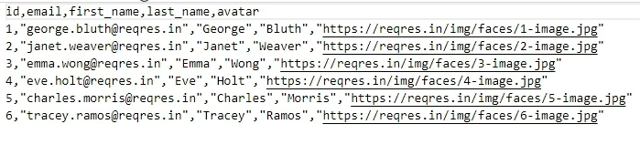

1. Create a container to store the API data.

1. Create a pipeline in azure data factory and select Copy data activities.

In Source select the Source dataset as REST.

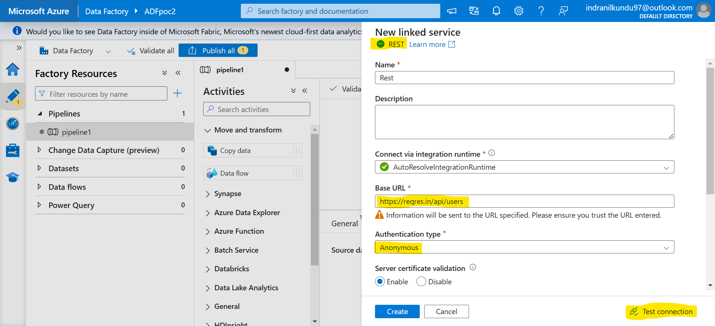

You can click on Preview data to see the data is coming or not.

In Sink select Sink dataset as Blob storage & format CSV type and select the folder file path where you want to store the data.

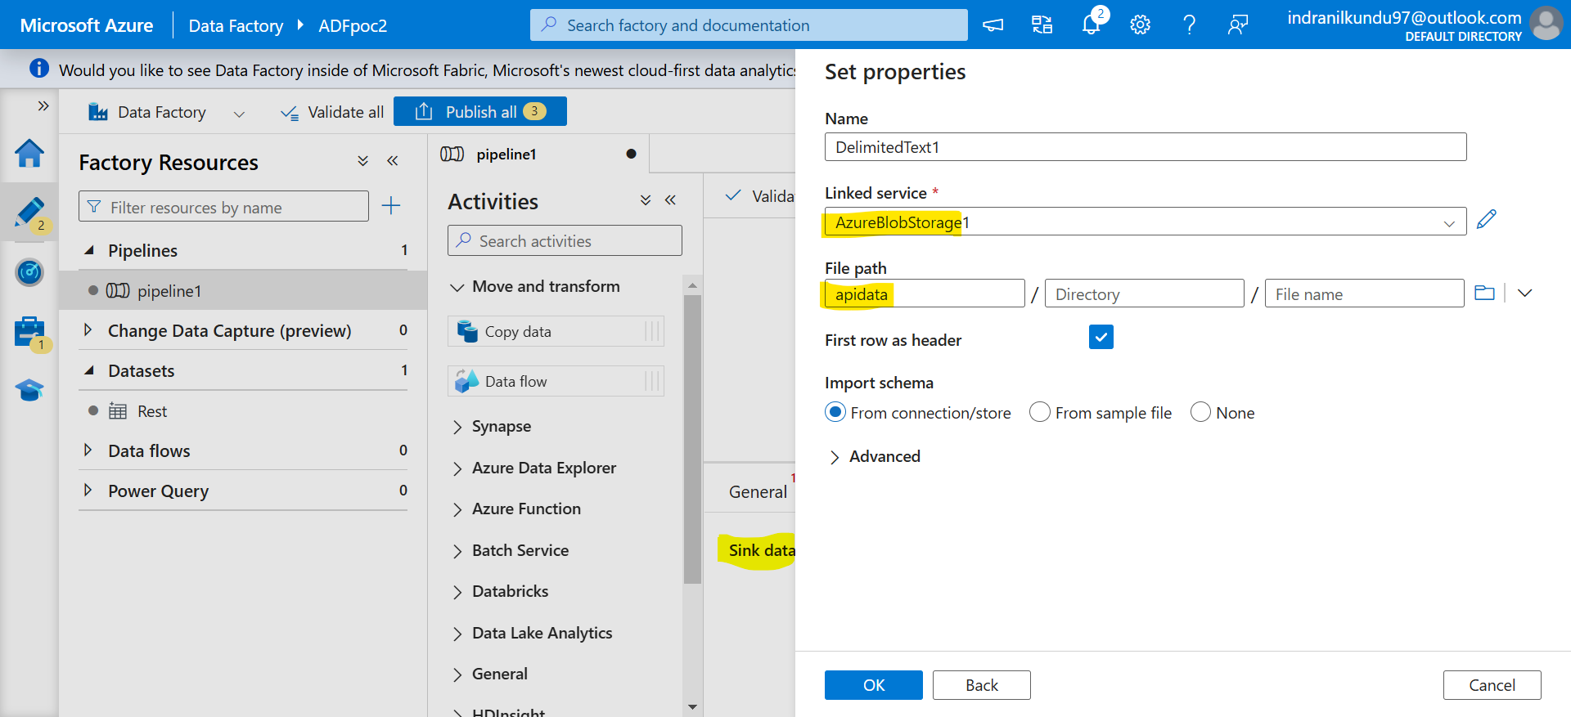

Go to Mapping -> select Collection reference as $[‘data’] -> select Import schemas -> select which columns you want to keep and delete others.

1. Click on Validate all -> Publish all -> Trigger Now to start the pipeline -> Monitor the pipeline.

1. Check the container that the required data is copied or not.

